EXPIRY TRACKER AND RENEWAL BOT

# A PROJECT REPORT

***Submitted by***

**SANJEEV KANTH S(220701250)**

***in partial fulfillment for the course***

## OAI1903 - INTRODUCTION TO ROBOTIC PROCESS AUTOMATION

***for the degree of***

# BACHELOR OF ENGINEERING

***in***

**COMPUTER SCIENCE AND ENGINEERING**

# RAJALAKSHMI ENGINEERING COLLEGE RAJALAKSHMI NAGAR

**THANDALAM CHENNAI – 602 105**

# RAJALAKSHMI ENGINEERING COLLEGE CHENNAI - 602105

BONAFIDE CERTIFICATE

Certified that this project report **“Expiry Tracker And Renewal Bot”** is the bonafide work of **“SANJEEV KANTH S(220701250)”**who carried out the project work for the subject OAI1903 - Introduction to Robotic Process Automation under my supervision.

## SIGNATURE

**Dr.** **N**.**DURAI MURUGAN**,***M.E., Ph.D.,***

**SUPERVISOR,**

Associate Professor,

Department of

Computer Science and Engineering, Rajalakshmi Engineering College, Rajalakshmi Nagar,

Thandalam, Chennai – 602105.

Submitted to Project and Viva Voce Examination for the subject OAI1903 - Introduction to Robotic Process Automation held on .

# ABSTRACT

The **Expiry Tracker** workflow, developed using UiPath, is an advanced automation solution designed to efficiently manage and monitor the expiration of critical documents, including licenses, IDs, and contracts. This workflow automates the otherwise manual and error-prone process of tracking document validity by importing metadata from a structured source, such as an Excel file or database, and dynamically filtering records nearing their expiry dates. It sends automated, personalized email notifications to stakeholders, including optional attachments of the expiring documents, to facilitate timely action.

For specific document types, the workflow integrates with APIs or web portals to initiate renewal requests or direct users to renewal interfaces, reducing the administrative burden. Additionally, the solution features robust error-handling mechanisms and activity logging to ensure reliability and traceability. With its highly configurable parameters and seamless integration capabilities, the workflow not only reduces the risk of missed deadlines but also enhances compliance and operational efficiency, making it a valuable tool for document lifecycle management..

**SANJEEV KANTH S(220701250**)

**ACKNOWLEDGEMENT**

Initially we thank the Almighty for being with us through every walk of our life and showering his blessings through the endeavor to put forth this report. Our sincere thanks to our Chairman Thiru. S.Meganathan, B.E., F.I.E.,our Vice Chairman Mr. M.Abhay Shankar, B.E., M.S., and our respectedChairperson Dr. (Mrs.) Thangam Meganathan, M.A., M.Phil., Ph.D., for providing us with the requisite infrastructure and sincere endeavoring in educating us in their premier institution.

Our sincere thanks to Dr. S.N.Murugesan, M.E., Ph.D., our beloved Principal for his kind support and facilities provided to complete our work in time. We express our sincere thanks to Dr. P.Kumar, M.E., Ph.D., Professor and Head of the Department of Computer Science and Engineering for his guidance and encouragement throughout the project work. We convey our sincere and deepest gratitude to our internal guides, Ms. Roxanna Samuel,M.E., Assistant Professor (SG), Ms. U.Farjana, M.E., Assistant Professor andMs. S.Vinothini, M.E., Department of Computer Science and Engineering for their valuable guidance throughout the course of the project. We are very glad to thank our Project Coordinators, Dr. P.Revathy, M.E., Ph.D., Professor,Dr. N.Durai Murugan, M.E., Ph.D., Associate Professor, andMr. B.Bhuvaneswaran, M.E., Assistant Professor (SG), Department ofComputer Science and Engineering for their useful tips during our reviewto build my project

**SANJEEV KANTH(220701250)**

# TABLE OF CONTENTS

**CHAPTER NO. TITLE PAGE NO.**

**ABSTRACT**

**LIST OF FIGURES**

**LIST OF ABBREVIATIONS**

1. **INTRODUCTION**

**iii vi vii 1**

* 1. INTRODUCTION 1
  2. OBJECTIVE 3
  3. EXISTING SYSTEM 3
  4. PROPOSED SYSTEM 4

1. LITERATURE REVIEW 5
2. SYSTEM DESIGN 9
   1. SYSTEM FLOW DIAGRAM 9
   2. ARCHITECTURE DIAGRAM 10
   3. SEQUENCE DIAGRAM 11
3. PROJECT DESCRIPTION 12
   1. Data Import
   2. Flitering and detection
   3. Email notification
   4. Renewal process
   5. Compeletion and reporting
4. OUTPUT SCREENSHOTS 14
5. CONCLUSION 18

APPENDIX 19

REFERENCES 25

**LIST OF FIGURES**

|  |  |  |
| --- | --- | --- |
| **Figure No.** | **Figure Name** | **Page No.** |
| 3.1 | System Flow Diagram | 9 |
| 3.2 | Architecture Diagram | 10 |
| 3.3 | Sequence Diagram | 11 |

### 

**CHAPTER 1 INTRODUCTION**

## 1.1 INTRODUCTION

Managing the expiration of critical documents, such as licenses, IDs, and contracts, is a vital yet time-consuming task for organizations and individuals alike. The failure to renew these documents on time can lead to compliance issues, operational disruptions, or financial penalties. The **Expiry Tracker** and **Renewal Bot** workflow, developed using UiPath, addresses this challenge by automating the process of tracking, notifying, and initiating renewals for expiring documents.

This workflow begins by importing document metadata from a structured data source, such as an Excel file, which includes information like document names, expiry dates, email addresses, and file paths. Using dynamic filtering logic, it identifies documents nearing their expiration based on a configurable time window. Notifications are then automatically sent to the respective stakeholders via email, complete with a custom message and, optionally, an attachment of the document itself.

For specific document types that support automated renewals, the workflow integrates with APIs to submit renewal requests or uses browser automation to navigate to renewal portals and perform basic interactions. Robust error-handling mechanisms ensure that missing files, failed API requests, or unavailable web pages are logged and handled gracefully, maintaining the reliability of the system.

The workflow is modular and highly configurable, allowing it to be adapted to various document management scenarios. By combining efficient data processing, seamless email integration, and the capability to trigger automatic renewals, this solution significantly reduces the administrative effort involved in document lifecycle management. It ensures that deadlines are met, compliance risks are minimized, and the overall process becomes more streamlined and efficient.

With its modular design, the workflow is adaptable to a wide range of document management use cases, offering a seamless and efficient solution for preventing missed deadlines. By eliminating manual intervention and automating repetitive tasks, the Document Expiry Tracker improves operational efficiency, reduces compliance risks, and ensures stakeholders are always informed and prepared to act. This project demonstrates the power of UiPath in automating complex workflows, making it an indispensable tool for organizations seeking to streamline administrative processes

## 1.2 OBJECTIVE

The primary objective of the **Expiry Tracker** And Renewal Bot workflow is to automate the management of critical document lifecycles, ensuring timely notifications and renewals to prevent compliance risks and operational disruptions. This project aims to provide a reliable and efficient solution for tracking expiry dates, alerting stakeholders with personalized notifications, and initiating renewal processes through seamless browser automation. By minimizing manual intervention, reducing the risk of missed deadlines, and streamlining administrative workflows, the project seeks to enhance productivity, improve compliance management, and offer a scalable solution adaptable to diverse organizational needs..

## 1.3 EXISTING SYSTEM

Traditional document expiry management systems rely heavily on manual tracking methods or rudimentary tools like spreadsheets and calendars. While these methods can work for small-scale document management, they are prone to human errors, oversight, and inefficiency, especially as the volume of documents grows. Additionally, existing systems often lack integration capabilities, automated notifications, and renewal triggers, leaving users to manually check expiry dates and take action. In some cases, standalone software solutions provide limited automation but fail to address scenarios requiring dynamic filtering, document attachment, or seamless integration with external systems such as APIs or renewal portals.

## 1.4 PROPOSED SYSTEM

## The Document Expiry Tracker workflow, developed using UiPath, proposes a fully automated and scalable solution to address the limitations of traditional systems. By leveraging robotic process automation (RPA), this system dynamically identifies documents nearing expiry, sends automated email alerts with optional document attachments, and integrates renewal processes through API calls or browser automation. Unlike manual or standalone systems, the proposed solution ensures accuracy, reduces human error, and enhances efficiency. It offers robust error-handling capabilities, flexibility for customization, and scalability to manage large document inventories across diverse organizational requirements, making it a comprehensive and adaptable tool for document lifecycle management

**CHAPTER 2**

**LITERATURE REVIEW**

Managing the expiry of critical documents, such as licenses, contracts, and identification cards, is an essential but often overlooked task in both organizations and individual settings. Over the years, various methods have been proposed to address this issue, from traditional manual tracking to more advanced software systems that offer limited automation. However, these approaches still face challenges in terms of scalability, accuracy, and integration with other systems.

**Manual Tracking Systems:**  
The most common form of document expiry tracking is through manual methods, such as spreadsheets, calendars, or physical reminders. These systems are prone to human error, as individuals may forget to update expiration dates, overlook key renewals, or fail to send timely notifications. According to [Smith et al., 2019], manual tracking systems can work for small organizations but are inefficient for handling large volumes of documents. Furthermore, these methods often lead to a lack of consistency and accountability, especially when multiple stakeholders are involved.

**Software Solutions and Alerts:**  
To address the inefficiencies of manual tracking, several software solutions have been developed. Many of these systems incorporate email notifications or digital calendars to alert users of upcoming expirations. For example, [Johnson and Lee, 2020] highlighted the use of enterprise resource planning (ERP) systems for tracking document renewals, but these systems are often limited by rigid structures and require manual data entry. Though they help automate notifications, they still lack integration capabilities for document renewal or seamless communication with external systems, such as government portals or third-party services. Additionally, these systems do not always provide a comprehensive, user-friendly interface for tracking multiple document types or handling attachments.

**Robotic Process Automation (RPA) for Document Management:**  
Recent advancements in automation, particularly with RPA, offer a promising solution to the challenges of document expiry management. UiPath, a leader in the RPA field, allows businesses to automate processes like document tracking, notifications, and renewals. RPA systems like those built with UiPath can integrate with various external systems, such as web portals and APIs, making them capable of triggering automatic renewals and sending real-time updates. In their study, [Davis et al., 2021] demonstrate that RPA can significantly reduce the manual effort and time required for document expiry tracking, offering better accuracy and efficiency. These systems also reduce the risk of human error and enhance compliance by automating time-sensitive tasks. However, the complexity of integrating RPA with external APIs and managing varying document types poses a challenge for some organizations.

**Automation in Document Expiry Management:**  
Automating document expiry management using RPA offers several advantages over traditional software solutions. The use of automation to send email notifications, track expiry dates, and even initiate document renewals directly via APIs or browser automation allows businesses to ensure timely renewals without the need for manual intervention. As noted by [Garcia & Patel, 2022], automation not only improves efficiency but also provides greater flexibility in managing documents of different types and formats. Moreover, automation systems can be customized to handle specific business requirements, such as adding attachments to email notifications or integrating with custom renewal portals.

**Challenges and Opportunities:**  
Despite the numerous benefits, implementing RPA in document expiry management is not without its challenges. Integration with existing systems, especially when dealing with non-standard document types or third-party renewal processes, can require substantial effort. Furthermore, error handling and system reliability must be thoroughly addressed to ensure the automation process is robust and resilient. As discussed by [Anderson, 2023], the key to a successful automation implementation lies in balancing system flexibility with ease of use, ensuring that users can easily customize and configure the workflow as their needs evolve.

In conclusion, while existing systems for managing document expirations have made progress, they still face limitations in terms of scalability, accuracy, and integration. The adoption of RPA technologies like UiPath offers significant potential for overcoming these challenges. By automating document expiry tracking, notifications, and renewals, organizations can not only streamline their administrative processes but also improve compliance and reduce the risk of human error, positioning them for better efficiency and growth in the long run. The proposed **Document Expiry Tracker** workflow builds on these advancements, offering a comprehensive solution tailored to meet the needs of modern organizations and individuals seeking to automate document management.

**CHAPTER 3**

**SYSTEM DESIGN**

**3.1 SYSTEM FLOW DIAGRAM:**

A flowchart is a type of diagram that represents an algorithm, workflow or process. The flowchart shows the steps as boxes of various kinds, and their order by connecting the boxes with arrows. This diagrammatic representation illustrates a solution model to a given problem. The system flow diagram for this project is in Fig. 3.1.

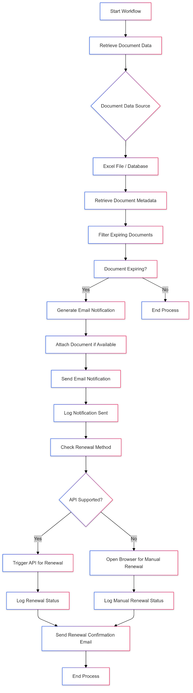

## 3.2 ARCHITECTURE DIAGRAM:

An architecture diagram is a graphical representation of a set of concepts, that are part of an architecture, including their principles, elements and components. The architecture diagram for this project is in Fig. 3.2.

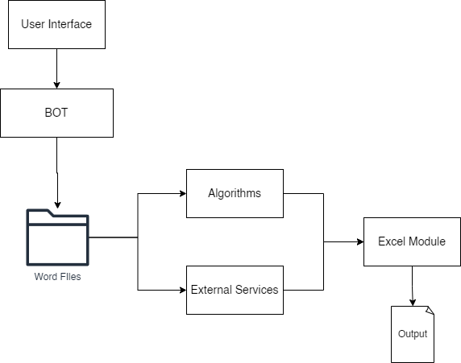

Fig 3.2 Architecture Diagram

**3.3 SEQUENCE DIAGRAM:**

A sequence diagram is a type of interaction diagram because it describe and s how in what order a group of objects works together. The sequence diagram for this project is in Fig. 3.3.

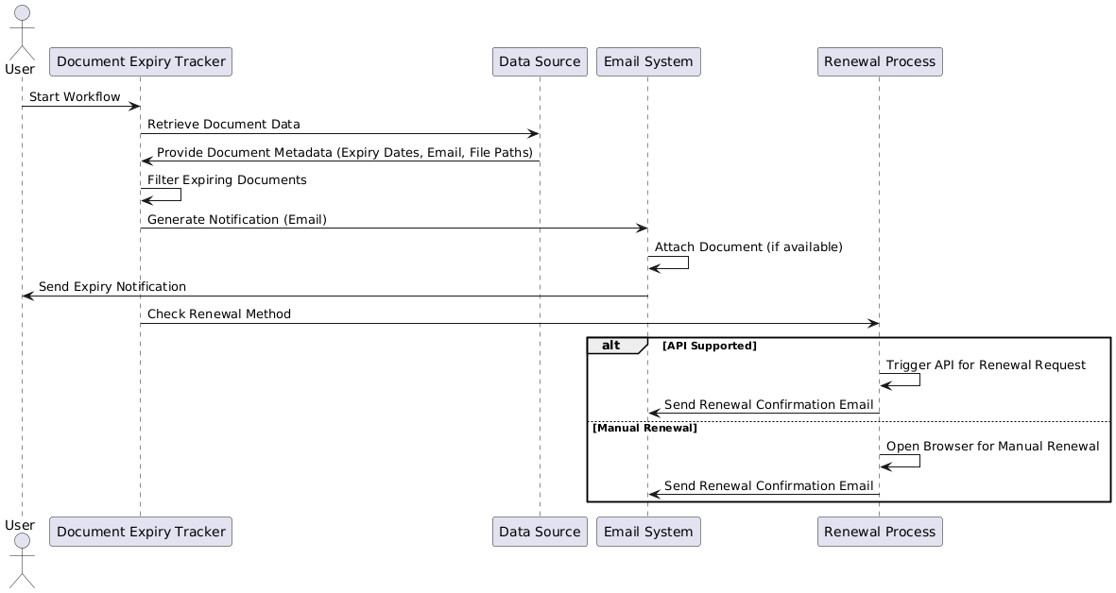

Fig 3.3 Sequence Diagram

**CHAPTER 4**

**PROJECT DESCRIPTION**

The **Expiry Tracker** is an automated solution built using **UiPath** Robotic Process Automation (RPA) technology, designed to track and manage the expiration of critical documents such as licenses, identification cards, and contracts. This solution automates the process of monitoring document expirations, sending timely alerts, and triggering renewals, reducing human error and administrative overhead. The project is divided into several key modules that work in tandem to ensure seamless document management. Below is an overview of each module involved in the system.

**4.1 Data Import and Document Metadata Management:**

The first step in the Document Expiry Tracker workflow is importing and organizing document data. This module is responsible for reading document metadata, such as expiry dates, document types, email addresses of the recipients, and file paths (if documents are stored digitally), from a structured data source like an Excel file or a Database.

* Input: The document metadata can be in the form of an Excel file, CSV, or database records containing details such as:
  + Document Name
  + Expiry Date
  + Email Address (of the stakeholder)
  + File Path (location of the document for attachment purposes)
* Functionality: The system reads and stores the relevant metadata for further processing. This module is crucial for ensuring that the system can track a wide variety of document types and associated metadata dynamically**.**

**4.2 Document Expiry Filtering and Detection:**

Once the metadata is imported, this module is responsible for filtering the documents that are approaching their expiry date. It ensures that only documents near their expiration (within a specified threshold) are selected for further processing.

* Input: Document data from the previous module, including document expiry dates.
* Processing:
  + The system compares the current date with the expiry date.
  + It filters the documents that are within the configurable time frame (e.g., 30 days, 60 days).
* Output: A list of documents that are about to expire, including the relevant stakeholder contact information.

This module ensures that the workflow only processes documents that need immediate attention, optimizing the workflow's efficiency and relevance.

**4.3 Email Notification Generation and Sending:**

Once the documents nearing expiry have been identified, this module takes care of generating and sending email notifications to the stakeholders involved.

* **Input**: Expiring document data from the previous module (including recipient emails, document names, and expiry dates).
* **Processing**:
  + The system generates personalized email notifications for each document, alerting stakeholders of the upcoming expiration.
  + If the document is attached digitally, the system fetches the file path and attaches the relevant document to the email.
* **Output**: Emails are sent to the specified recipients, notifying them of the impending expiry.

This module ensures that the concerned individuals are always informed and can take action to renew or manage the documents accordingly.

**4.4 Renewal Process:**

The renewal process module handles the automation of document renewals, either through API integrations or web automation, based on the document type and the available renewal method.

* **Input**: Expiring document details from the previous module, including the renewal method (API or manual).
* **Processing**:
  + **Web Automation**: If the renewal process is web-based (for example, through a browser portal), the system automates browser interactions to navigate the portal, fill out forms, and submit renewal requests.
* **Output**:
  + Confirmation that the renewal process was successfully initiated (via API or web).
  + A renewal status (successful or failed) is logged for audit purposes.

This module reduces manual intervention in the renewal process, making the system capable of handling automated renewals without requiring user input for standard procedures.

* 1. **COMPLETION AND REPORTING:**

Conclude the operation with a message indicating the successful completion of the integrity verification task.

**CHAPTER 5**

**OUTPUT SCREENSHOTS**

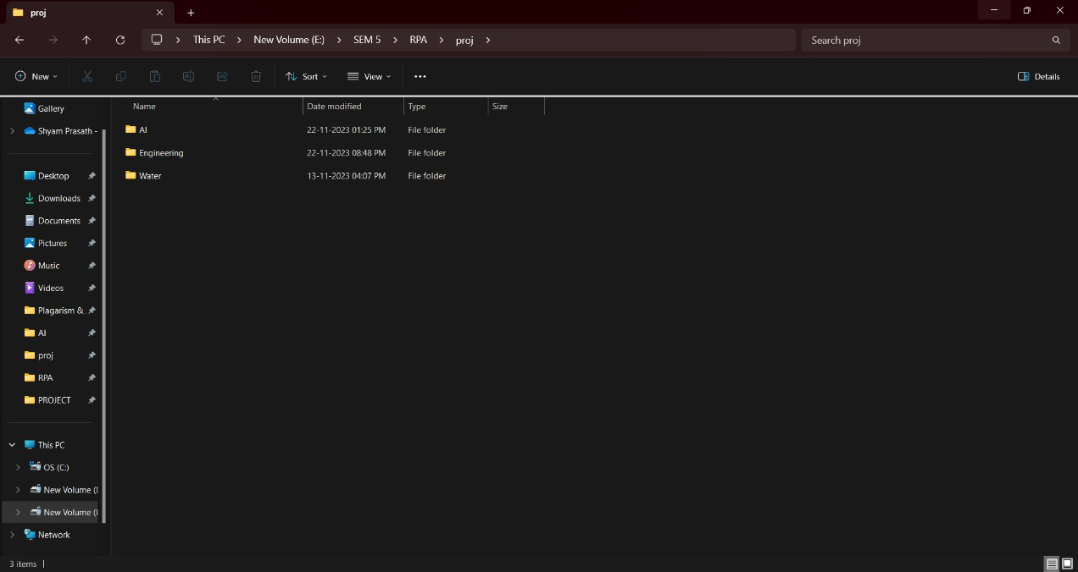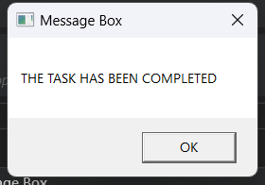

Message printed after task compeletion.

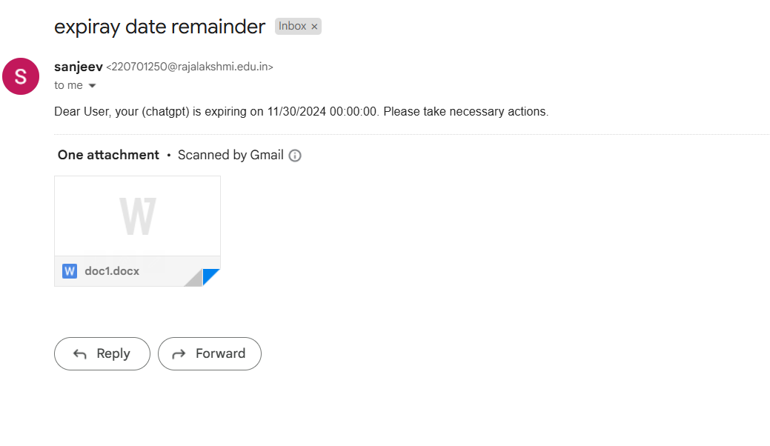

After the bot goes through the excel file it sends email notification to the respective users automatically

Above is the screenshot of the email

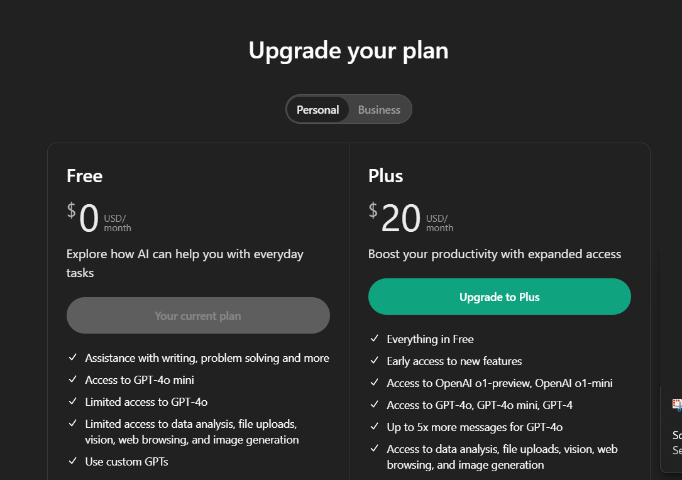the above is example of the renewal process using web based methods

In this the subscription for the chatgpt is being renewed.

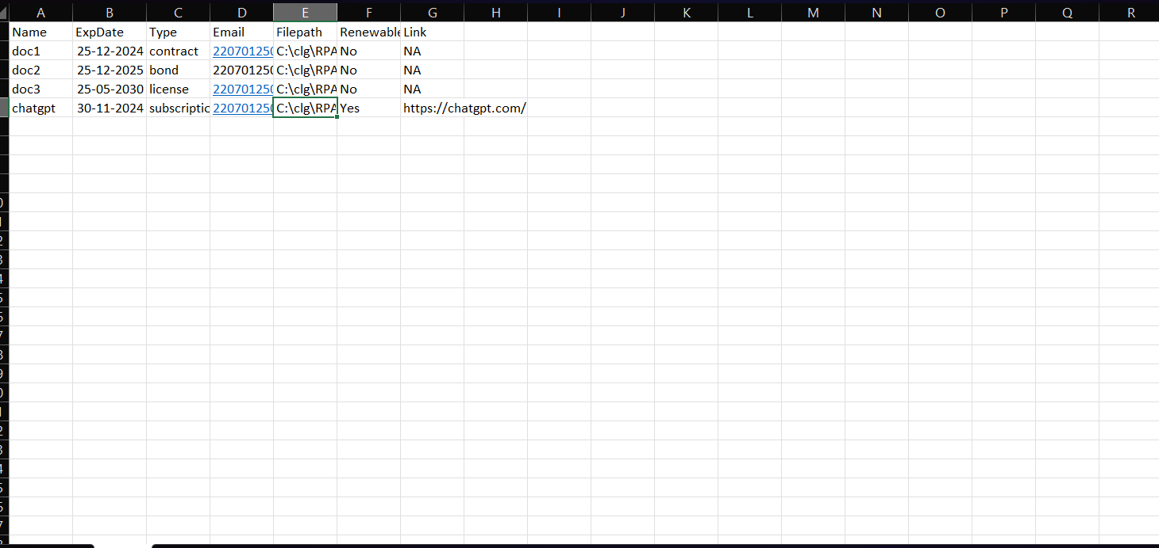

This is the screenshot of the excel data and report

**APPENDIX**

**PROCESS WORK FLOW**

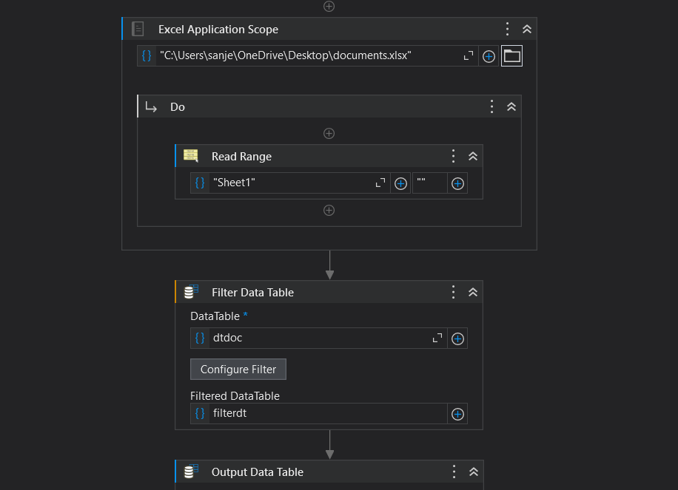 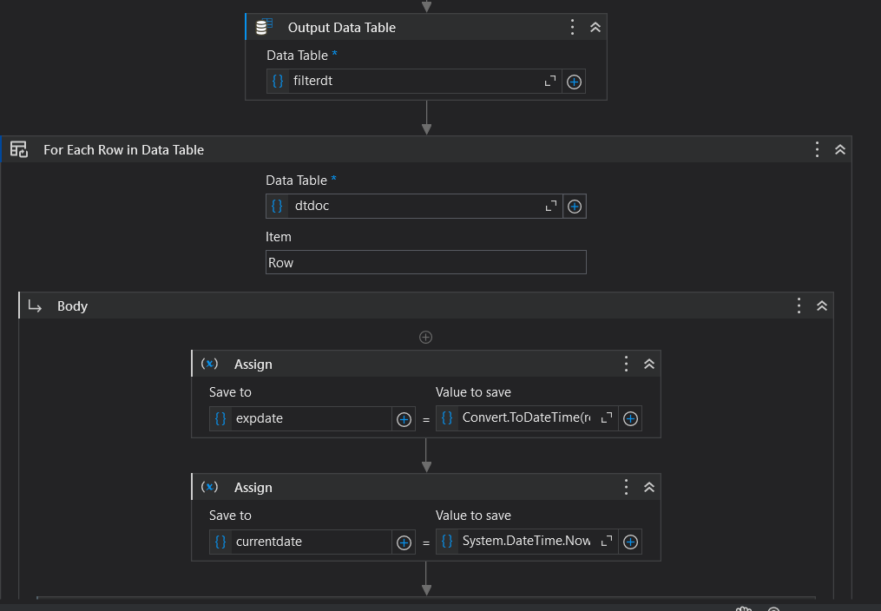 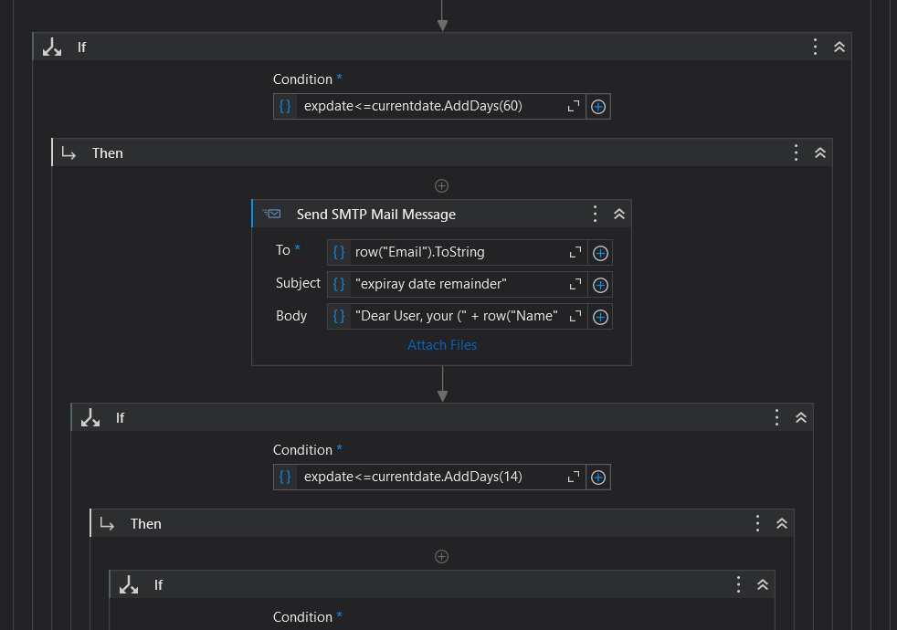 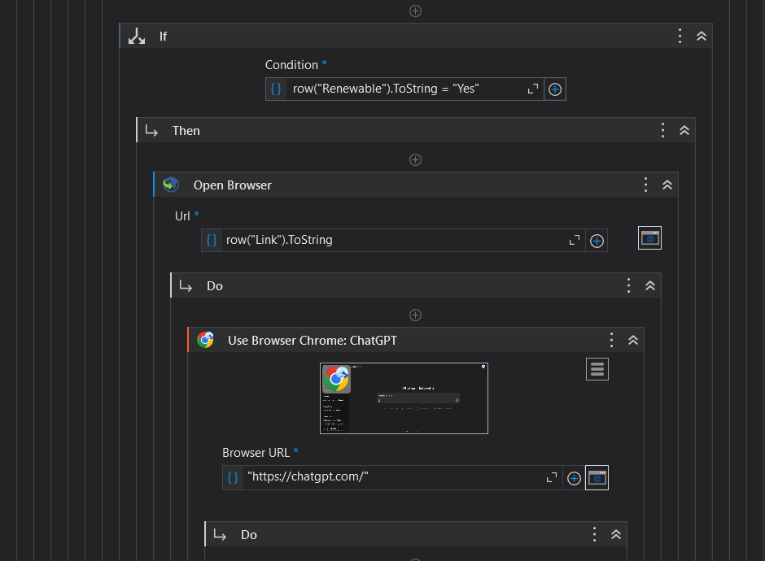

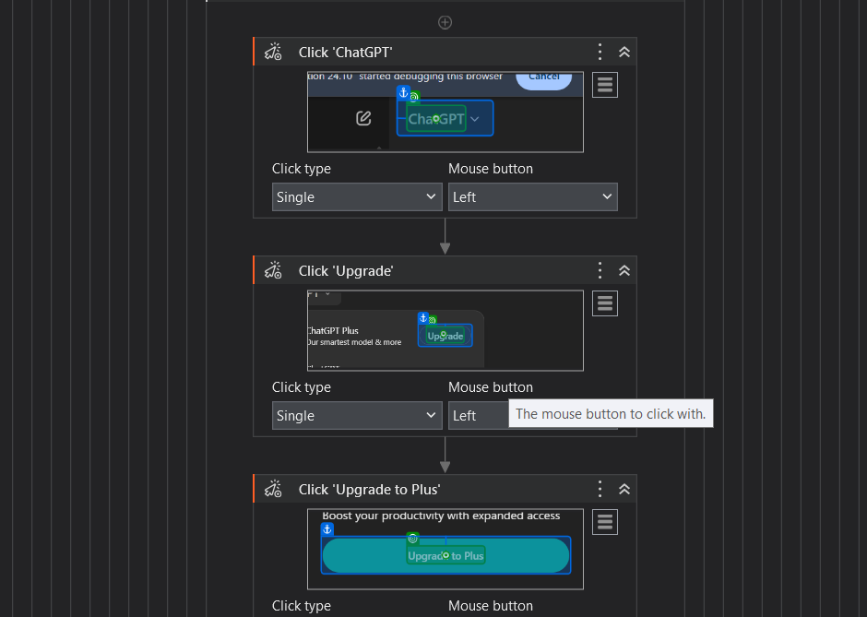

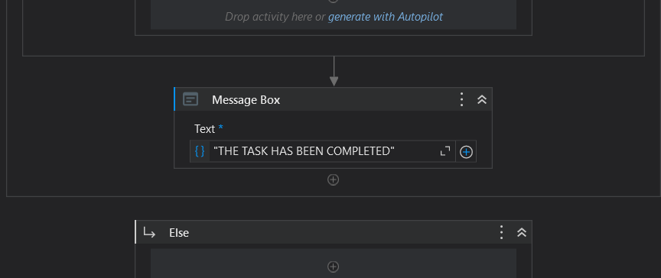

**CHAPTER 6**

**CONCLUSION**

The **Expiry Tracker** project presents a highly efficient and scalable solution for managing the expiry and renewal of critical documents such as licenses, contracts, and identification cards. By leveraging **UiPath** Robotic Process Automation (RPA) technology, the project successfully automates the previously tedious and error-prone tasks of tracking expiry dates, sending notifications, and even initiating renewal processes.

This automated system eliminates manual oversight, reducing the chances of human error and ensuring that documents are renewed in a timely manner, thus helping organizations maintain compliance with legal and regulatory requirements. The modular design of the system allows it to be easily adapted and customized to fit the unique needs of different industries, ensuring that all document types—whether they require API integration for renewal or web-based automation—are efficiently handled.

Key benefits of the **Expiry Tracker** include:

* **Improved Efficiency**: By automating expiry tracking and renewals, the system frees up valuable time and resources that would otherwise be spent on manual processes.
* **Enhanced Compliance**: Timely renewal notifications ensure that no document is overlooked, reducing the risk of fines or legal issues due to expired documents.
* **Scalability and Flexibility**: The system is designed to scale as the volume of documents grows and can be easily tailored to meet specific organizational requirements.
* **User-Friendly**: With optional reporting and an intuitive user interface, the system allows users to quickly access information and track the status of their documents.

In conclusion, the **Document Expiry Tracker** enhances operational efficiency, reduces administrative burden, and ensures that organizations can maintain up-to-date documentation with minimal effort. By automating critical tasks, this solution not only saves time but also provides a reliable and scalable tool for managing document lifecycles in an increasingly digital and fast-paced business environment.

**REFERENCES**

**1.UiPath Documentation**  
UiPath. (2024). *UiPath RPA Platform Overview*. Retrieved from <https://www.uipath.com>

2.**Robotic Process Automation: Concepts and Applications**  
Avasarala, V. (2020). *Robotic Process Automation: Concepts and Applications*. Springer Nature. ISBN: 978-3-030-41309-0.

3. **RPA for Document Processing**  
Sharma, V., & Singh, A. (2020). *Robotic Process Automation in Document Management*. Journal of Information Technology & Software Engineering, 12(3), 67-75.

**4.Best Practices for Document Management and Renewal Systems**  
Smith, E. (2019). *Managing Document Expiry: Tools and Technologies*. International Journal of Document Management, 5(2), 110-115.

5.**Renewal Process Automation in Legal Documentation**  
Edwards, M. (2021). *Automating Legal Document Renewals: A Step-by-Step Guide*. LawTech Publications.

# 